Yifu Huang & Kiernan Akers

EE 371R Project Proposal

September 19, 2019

Distracted Driving Detection through Facial Expression Recognition based on Raspberry Pi

**Introduction**: According to the National Highway Traffic Safety Administration (NHTSA) Distracted driving is any activity that diverts attention from driving, including talking or texting on your phone, eating and drinking, talking to people in your vehicle, fiddling with the stereo, entertainment or navigation system—anything that takes your attention away from the task of safe driving. Distracted driving can affect anyone, regardless of age, biological sex, or driving experience. One strategy for deterring drivers from engaging in distracting activities is to utilize positive punishment, or a negative consequence after an undesired behavior is exhibited. Our goal for this project is to devise a system that accurately detects when a driver is fatigued/distracted and then provides the user with an audible and visible alert that discourages them from driving in their current state.

**Materials/Methods**:

*Algorithm(s):* Convolutional Neural Network (CNN).

*Tools:* Raspberry Pi 4 with Camera Kit; Python 3; Keras, OpenCV.

*Dataset:*

1. State Farm Distracted Driver dataset on Kaggles.

<https://www.kaggle.com/c/state-farm-distracted-driver-detection>

1. Yawning Detection Dataset (YawDD) from ACM Multimedia Systems Conference Dataset Archive.

<http://www.site.uottawa.ca/~shervin/yawning/>

**Application**:

1. Distracted and fatigued driving detection;
2. Distracted class behavior detection.

**Expected Results:**

1. Accuracy of the detection model: > 0.93;
2. Logloss < 1.0

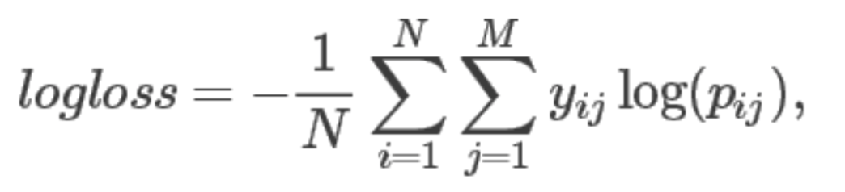

**Summary:**

This project would not only be able to detect the distracted behavior but also fatigued driving. The application of Raspberry would make the system portable and energy-conservative, which would offer capability for it to be applied on the cars continuously in real-time.